1. Gitlab Runner registration.

1. Pipeline stages successful.

1. Pipeline Build stage to build the docker image and push the image to ECR.

1. Docker Build Successful.

1. Docker image pushed to ECR.

1. Docker image present in ECR.

1. Kubernetes deployment job failure due to AWS memory db authentication issue.

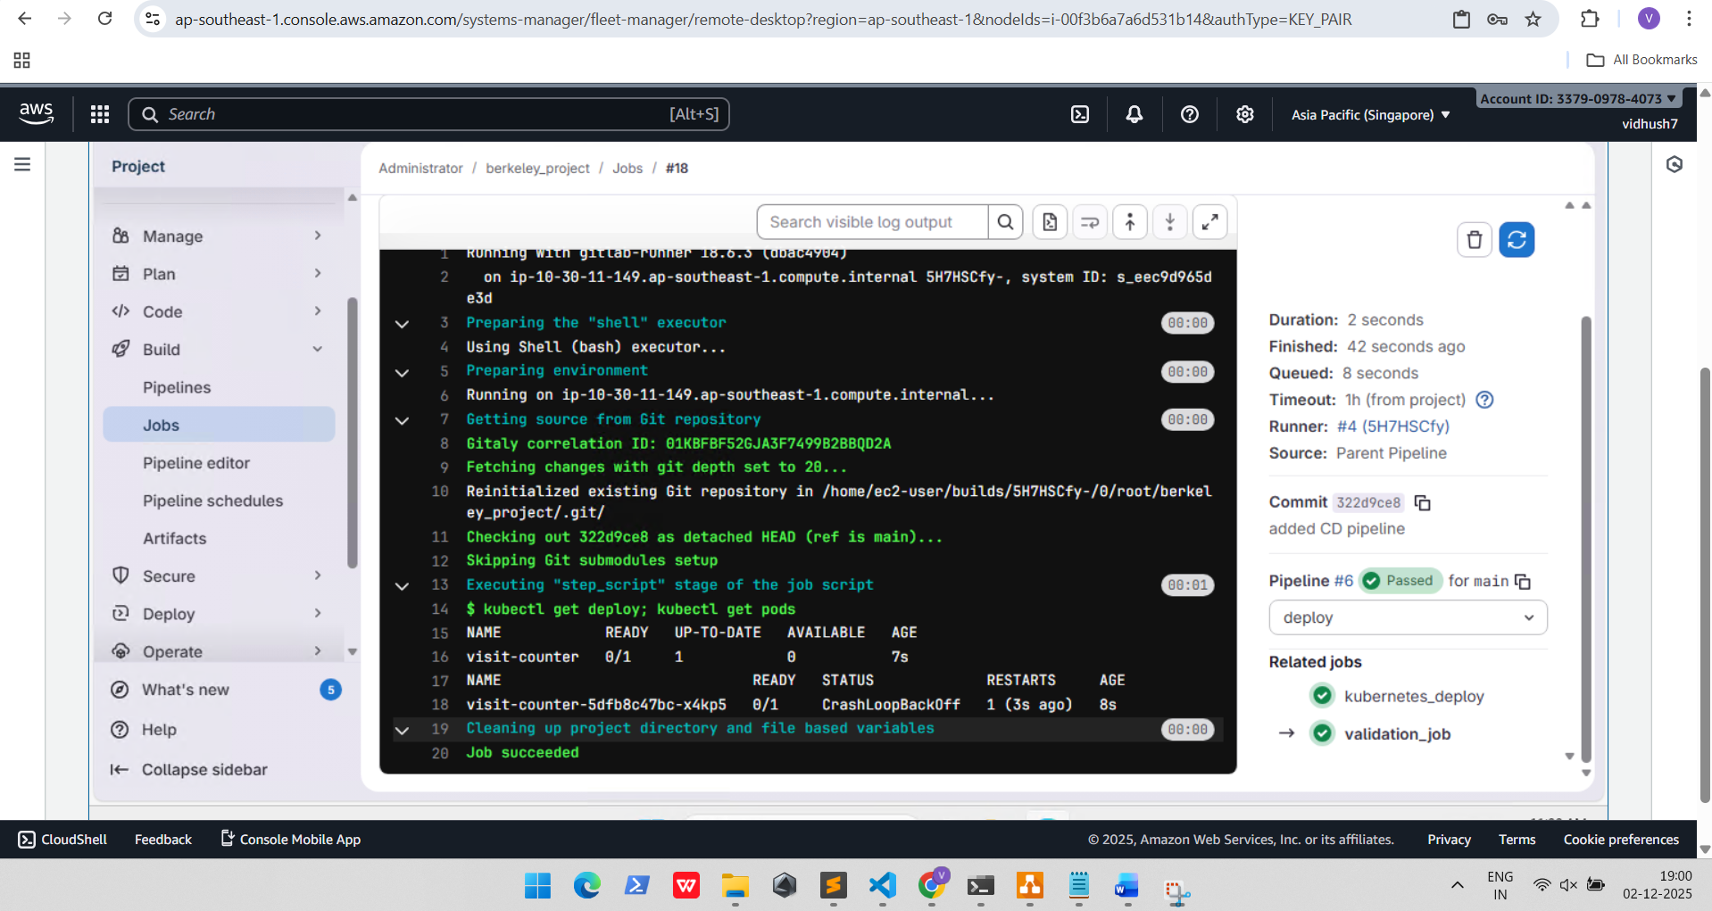

1. After issue resolution, Application pods are running without issues.

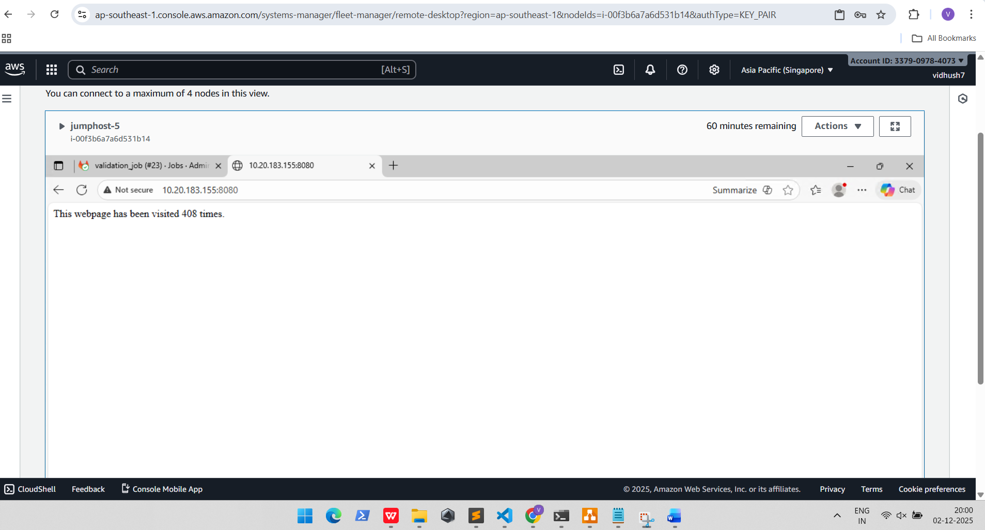

Resources built in AWS cloud:

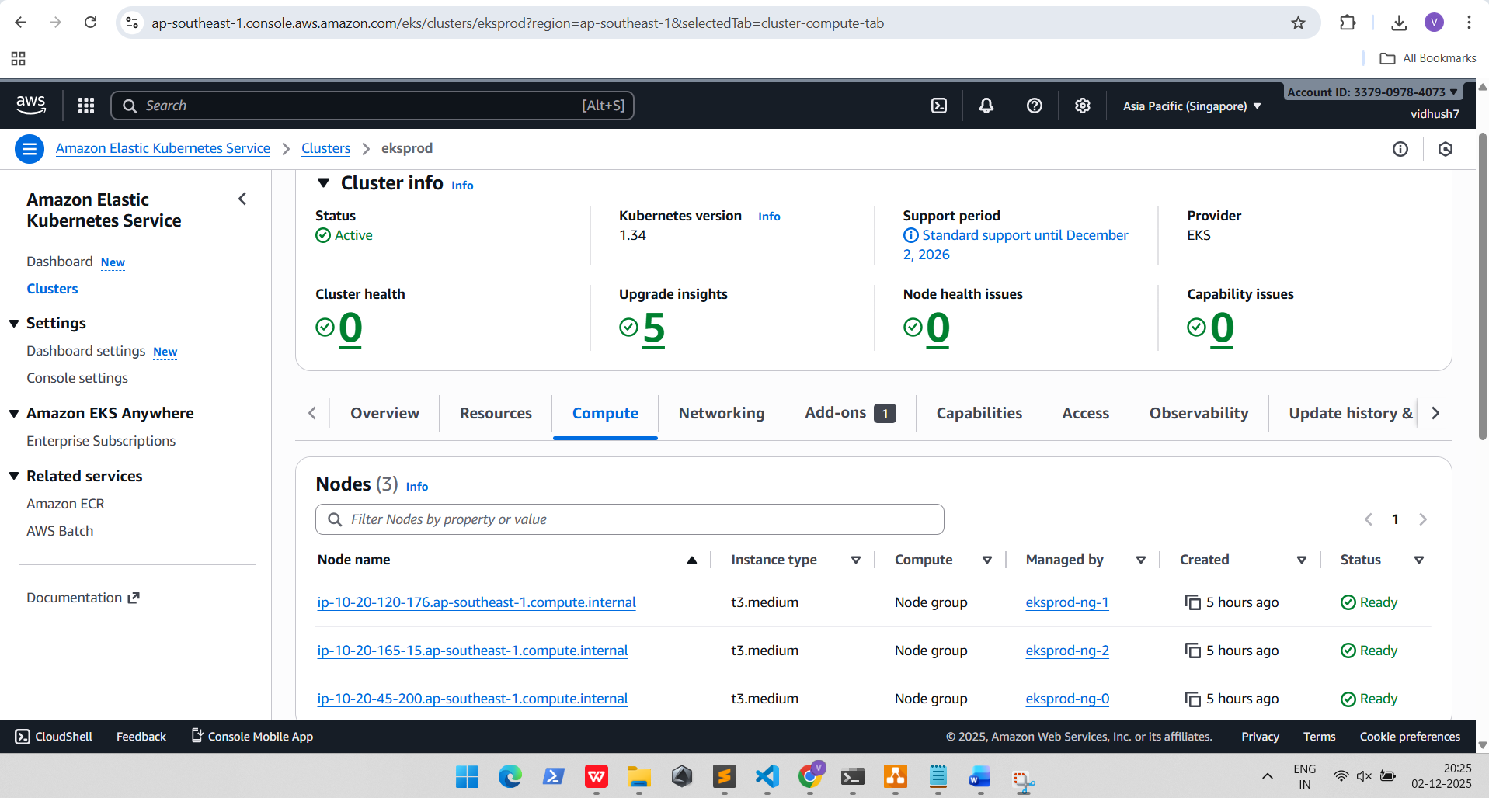

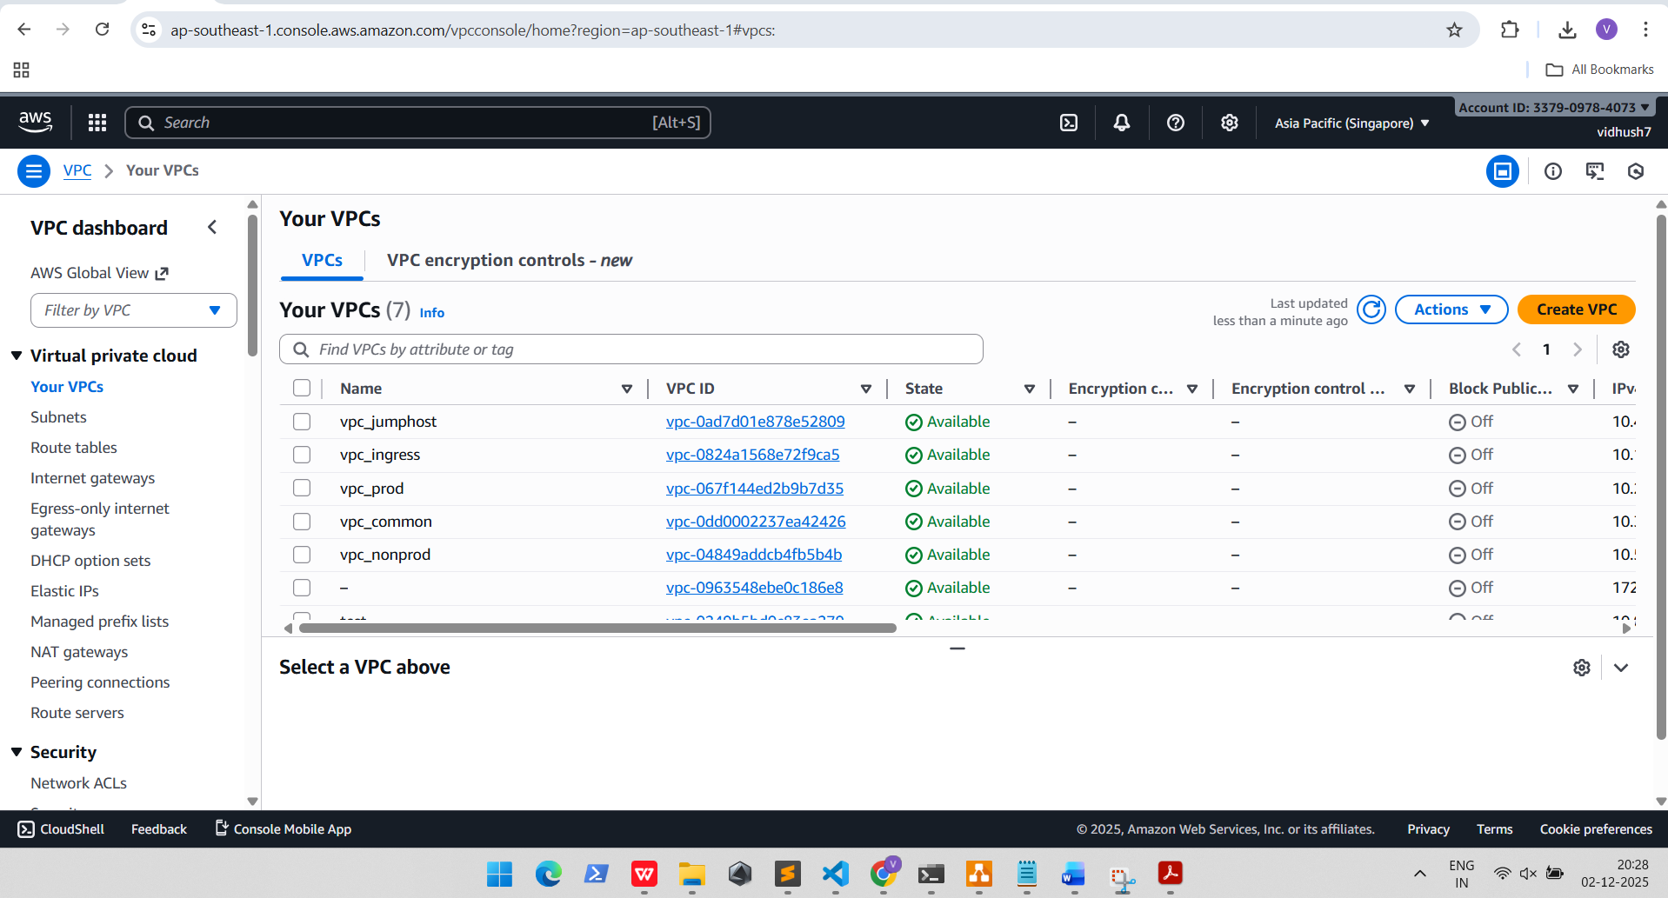

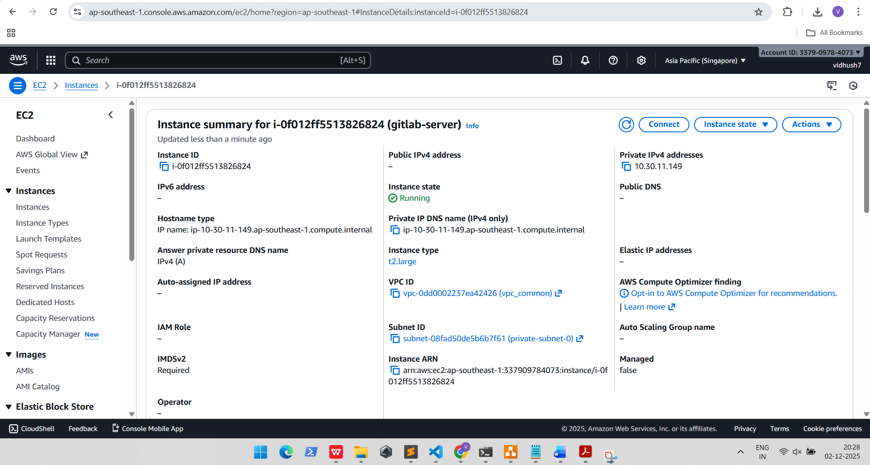

Application Functionality:

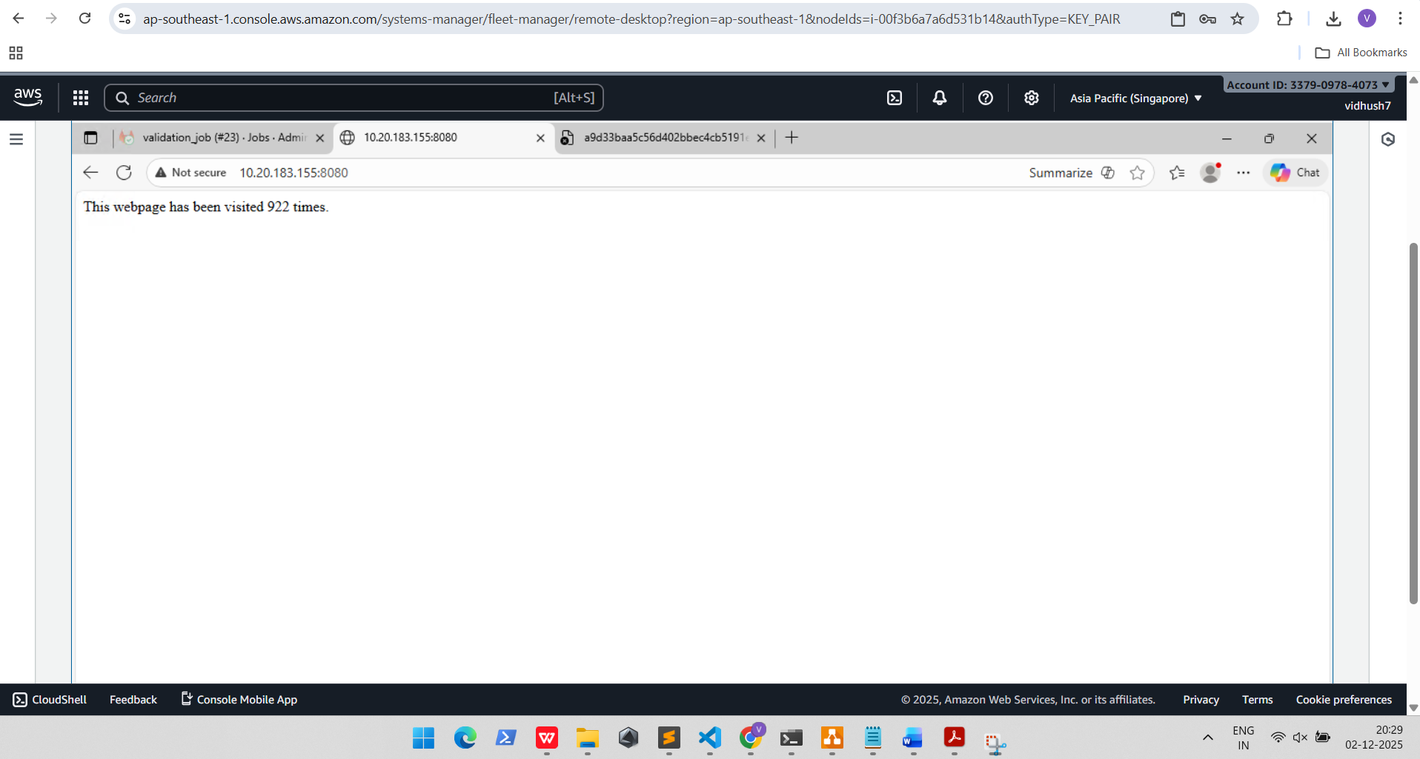

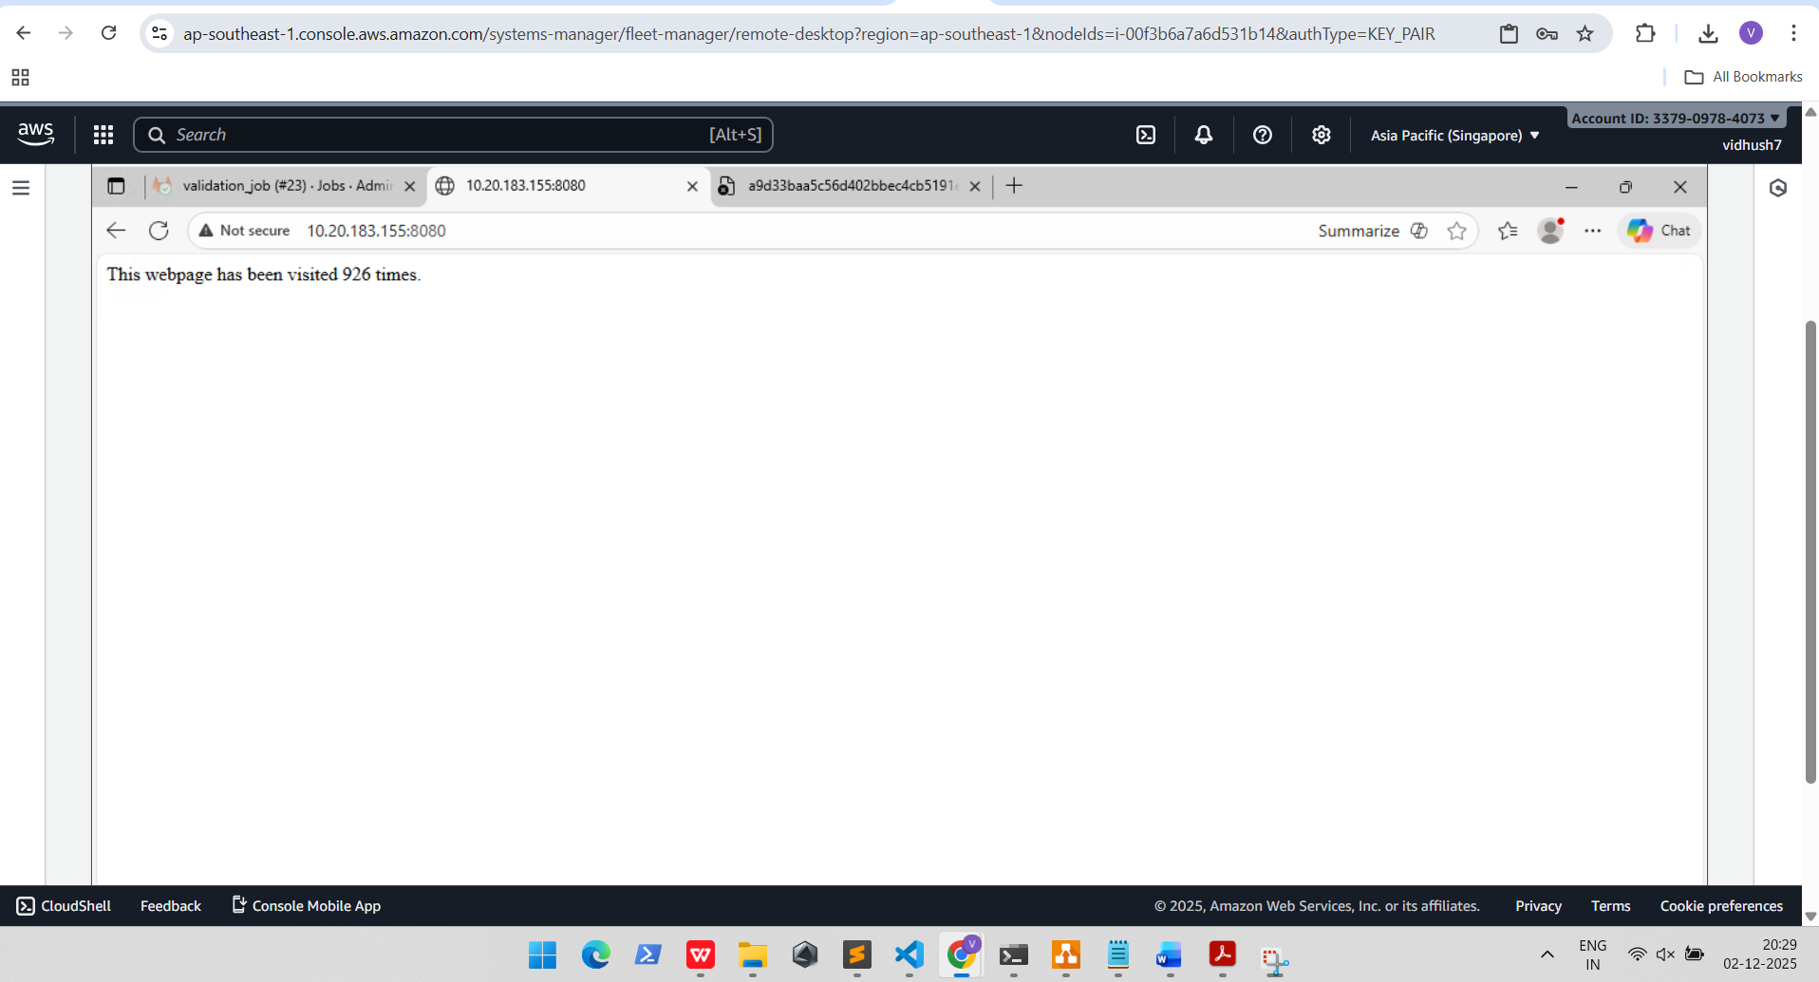

EKS Cluster resouces:

